m-ASK Feedback interaction with farmers

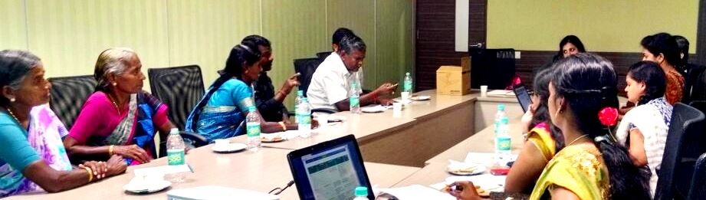

Venue: RTBI conference room Date: 15th December 2014

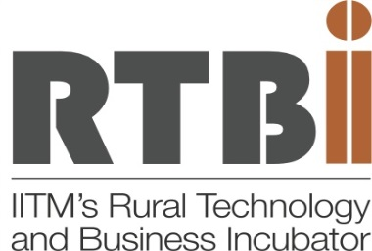

Prepared by
Archana. K. Prasad
U. Sangeetha

December 2014

TABLE OF CONTENTS:
S. No | Title
1. | Overview- Background
2. | Proceedings  - Expert Interaction on the farmer dashboard  - Plan for the coming months  - Video streaming  - Discussion on the future extension model:
3. | Way forward
4. | Appendix
5. | Plates

OVERVIEW- Background:
The m-ASK initiative has been deployed on a pilot scale from December 2012 in Nagar and Thirumangalam villages of the Lalgudi block in the Thiruchirapalli district of Tamil Nadu. The initiative focusses on personalised farmer services using individual dashboards, for registered farmers along with a mobile based update and advisory system to track the crop stage wise. As the initiative progressed the importance of field level participation was felt by the team and hence representative farmers were selected in September 2013 to motivate fellow farmers of the region and create awareness on the importance and use of such a technology. Mr. Rajagopal from Thirumangalam and Ms. Allirani from Nagar were selected as representative farmers who had helped mobilise farmers from two more villages of the Thiruchirapalli district, Viz. Ariyur and Anbil. The 112 farmers on board were contacted regularly for awareness, advisory and orientation by means of phone-calls, meetings and workshops. This had eventually helped in building a trust among farmers.
To understand the challenges faced by the farmers in interacting with the system and to understand the efficiency of the system it was necessary to get a feedback from the beneficiaries. The team felt that such interactions could help in improving the services. Accordingly, a few registered farmers were invited and interacted with the RTBI team on the 15th of December 2014 at the Research Park Conference Hall. Following is a report on the same.

PROCEEDINGS:
The forenoon session started with a welcome address by Ms. U. Sangeetha, followed by enlisting the achievements of the initiative since the pilot had started functioning in the Tiruchirappalli district. The farmers were given an insight on the timelines for a period of 2 years from the start till date, which is attached in the appendix.
- Expert Interaction on the farmer dashboard:
Followed by the welcome and the review of achievements Ms. Nathiya [Domain Expert], interacted with the farmers by demonstrating the farmer dashboard system. She presented the individual farmers dashboard and appreciated the farmer’s opinion for the same. Followed by which some aspects of the Samba survey results were shared among the farmers - they were very made aware of the cost of cultivation and the yield difference by comparing the baseline survey results and the 2013 samba season results (October 2013-February 2014). Farmers agreed that there was a noticeable reduction in the cost of cultivation after following the advisories provided through the mASK.
The farmers had expressed their challenges in interacting with the system; in particular, they wanted to see tangible benefits of calling to update the farmer dashboard and usage of the PDIU applications which is enlisted as “Challenges” in the appendix. The farmers also mentioned the need for information on region specific weather report, sources of quality seeds and inputs, subsidies on farm machineries, markets and price information, quality soil testing labs and new technologies.
- Plan for the coming months:
From the various interactions with State Department of Agriculture, Tamil Nadu Agricultural University, Industrial contacts, Interns and the registered farmers the team felt that there is an immediate need for market related information To know how to address this requirement, the team needs to understand what exactly is anticipated in terms of market information and what the purpose of acquiring such information was. The farmers were asked to come out with different suggestions which were noted down by the team for further discussion and dispensation.

- Sharing new technologies
Technology based video on soil testing and a presentation on drip irrigated paddy cultivation were ran to the farmers. The main objective of this session was to understand and interest for adoption of beneficial technology by way of sharing the learnings of the team. The team could identify the challenges faced by farmers in adopting the drip irrigated paddy cultivation in the delta districts as the clayey nature of the soil clogs the drip lines and thereby spoils the infrastructure. The video on soil testing was well received by the farmers and throughout the session a sense of gratitude and appreciation was felt towards the free soil testing initiative carried out by RTBI in the fields of the registered farmers. The farmers also felt that there were more number of fellow farmers enquiring about the benefits of soil testing after RTBI’s efforts had found success, which is considered as a major milestone by the team. Mr. Rajagopal, had appreciated RTBI for adopting a bottom up strategy in helping the farmers with soil testing, input advisories based on the soil test reports, crop stage-wise advisory, pest and disease management, harvest and post-harvest updates and information on Tamil Nadu Government schemes and subsidies. He feels that RTBI unlike other product or service specific organisations tries providing holistic services for the farmers.
With this sitting the forenoon session had come to an end, followed by which the farmers were taken for lunch at the Research park food court.
- Discussion on the future extension model:
The afternoon session began by summarising the forenoon discussions. Bearing in mind various challenges that were faced by the farmers and the technical issues, the team along with the farmers had initiated discussions on framing models way forward. The team had presented an agri clinic and pharmacy model that was set up at a Krishi Vigyan Kendra in Mysore who had recently approached RTBI for the adoption of the Farmer Dashboard services. As per the RTBI Director’s suggestion, the team tried to analyse the taking of such a model with the m-ASK beneficiaries. Farmers received the concept very well and proposed the dispensation of such advisories could be done through the farmer producer company that was to come into force from the month of January 2015. One of the representative farmers, Mr. Rajagopal felt that the advisories could be better transferred as the receiver end is a network of farmers rather an individual, also the farmer producer company is supporting approximately 250 farmers in the current network with the possibility of growing up to 1000 farmers by two crop cycles(approximately 6-8 months). The RTBI team felt there was a good avenue of scaling up its existing pilot initiative through the farmer producer company. It was also discussed to provide more information on the details discussed during the forenoon sessions. But, with the existing team at RTBI, the extent to which holistic information services can be provided to a greater population is to be seriously considered. Also the numbers of calls we receive from the present beneficiaries are at the rate of five calls a week. The registered farmers will have to pay approximately Rs.30 to Rs.50 per month based on the availed advisory services, internet charges and mobile application costs. Farmers felt that the amount will be a little expensive when it comes to an individual farmer, but can work out a feasible monthly subscription rate as a farmer producer company, to which the team has agreed to wait till the official launch of the company.
After the discussion the Director, RTBI had given her suggestions and raised a few questions for clarity in understanding the challenges that was faced by the farmers as well as the system, which the team had taken note of while discussing the way forward. Followed by which, Ms. Prasanna Priya delivered the vote of thanks. Farmers were gifted with mementos after which the evening tea was served before dispersing.
WAY FORWARD
The team had taken a note during the day’s proceedings, of the various challenges represented by the farmers and the issues that were found to exist in the system. It has made a list of all the points to be discussed and plans to conduct a brainstorming on the way forward in the presence of the Director and the Senior Manager (Agriculture Initiatives), RTBI. The brainstorming is scheduled on the 23rd of December 2014 at the RTBI conference room, which has allotted a one hour slot for exclusive discussions on the m-ASK initiatives.

APPENDIX-I
Team- RTBI
Suma Prashant - Director
Jayalakshmi Umadikar - Senior Manager Agri. Initiative
Archana. K. Prasad - Project Associate [Agriculture Initiatives]
U.Sangeetha - Project Associate [Agriculture Initiatives]
N. Prasanna Priya - Project Associate [Agriculture Initiatives]
P. Nathiya - Project Associate [Agriculture Initiatives]
Deapica Ravindran - Research Associate [Health Initiatives]

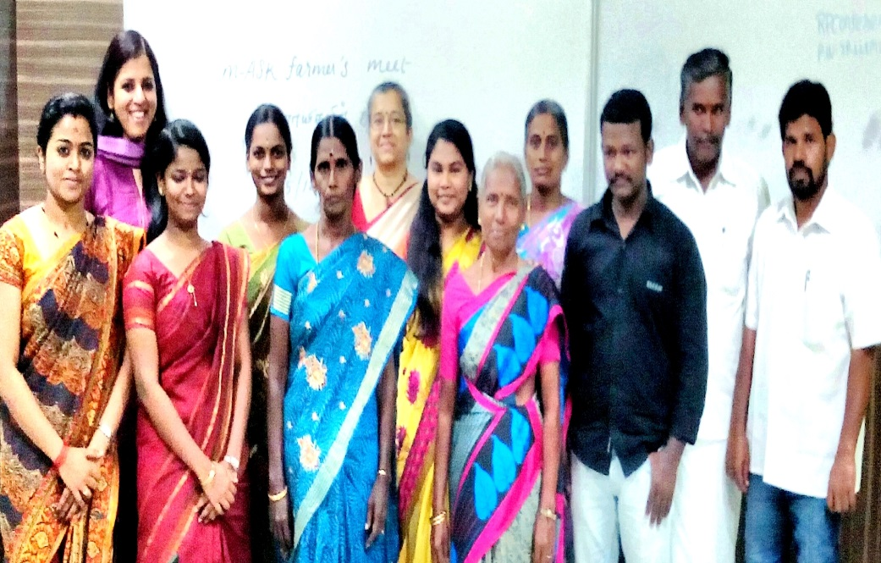
Farmer participants
N.Rajagopal - Thirumangalam
Udayasooryan - Thirumangalam
Vigneshwaran - Anbil
J.Allirani - Nagar
Josephine - Nagar
Leema Rose - Nagar

APPENDIX-II
AGENDA
5:00am-6:00am : Expected time of arrival
6:00am-8:30am : Freshen up
8:30am-9:00am : Breakfast
Forenoon session
9:30 am-10:00am : Welcome Address
An overview of achievements so far - Ms. Sangeetha
10:00am-11:00am : Expert interaction – Ms. Nathiya and Ms. Sangeetha
- Dashboard demonstration – In what stages what info need?
- Sharing of samba survey results
- Challenges on PDIU
- Further info needs from m-ASK?
11:00am-12:00am : Plan for coming months – Team
- Post harvesting challenges with specific focus on market information
- Subscription services
- Challenges for the above and farmer opinion
12:00-12:30pm : 1. Soil testing video -Ms. Nathiya and Ms. Sangeetha
Challenges of doing soil testing in future
2. Presentation on Drip irrigated paddy cultivation
Challenges of adopting drip irrigation
12:30pm-1:30pm : Lunch at food court
Afternoon Session
1:30pm-2:30pm : Discussion on future extension model
–Ms. Archana Prasad
2:30pm-3:00pm : Winding notes by the Director, RTBI
3:00pm : Vote of thanks- Ms. Prasanna Priya

APPENDIX-III
Achievements Timeline:
Date/Year | Achievement | Details
December 2012  February- March 2013 | Project Initiation  50 farmers on board
19th September 2013 | 2 Representative Farmers on board  Increase in number of calls for update and advisory | Mr. Rajagopal- Thirumangalam  Mrs. Alli Rani- Nagar
March 2014 | Samba Season Survey | Noticeable reduction in the cost of cultivation was observed with the registered farmers.  More number of farmers was found to follow the advisories given by the expert.
April 2014 | 52 more farmers on board from Anbil and Ariyur villages
 | Soil testing for registered farmers | Reliable soil test report for 112 registered farmers
 | Total number of calls | 257 calls-124 calls for the advisory and 133 calls for updates

APPENDIX-IV
CHALLENGES
Sl.No | Challenges | Recommendations
1 | m-ASK challenges:
 | What are the tangible benefits in updating the dashboard? | - Text messages for the given advisory- similar to just dial  - Can we look at relaying Voice advisories?  - Record keeping- compare cost of cultivation, yield and other plant protection factors- cross check with the farmers
 | PDIU application- network issues,  Poor handling  Android does not support  Prefer simpler version. | - Check with the technical team  - Try direct sending of the images via mail  - Training to youngsters
2 | Farmer’s challenges:
 | Seed – quality seeds not available, different sources of seeds which differ in quality and price, farmers generally tend to prefer BPT(Andhra Ponni) because of the low price*(Rs.25/kg) and better market price and yield, yet high amount of pest and disease infestations. Mill owners prefer BPT due to higher rice yield after husk removal (80/120 kg). | - Farmer producer company  - Group selling  - Seeds must be sourced directly from the producers who promise good quality pest and disease resistant varieties.  - Awareness on the producers list in each block.
 | No region specific weather data | - Try and relay information from reliable source
 | Farm machineries- availability, field demonstration.  More information-subsidies, schemes and loans, maintenance, rental, block level information | - Research on what, when and where new machineries are released, schemes and subsidies, suppliers list
 | Soil testing details | Get information on the reliable labs and access to them
 | Marketing | Marketing survey- Identify what market information is sought by farmers and try to address challenge
 | Labour

PLATE
- Representative farmers enlisting their challenges:
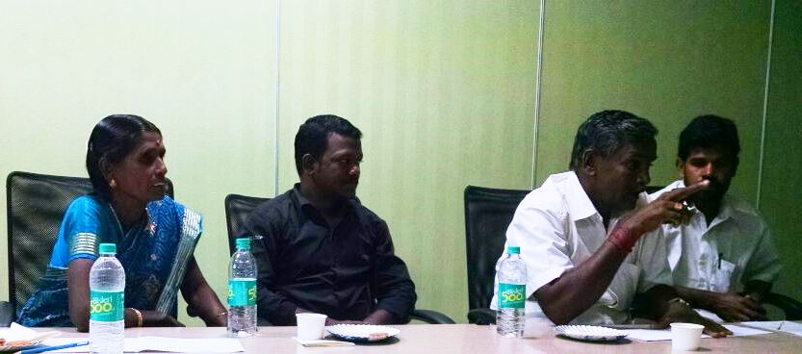
- The forum
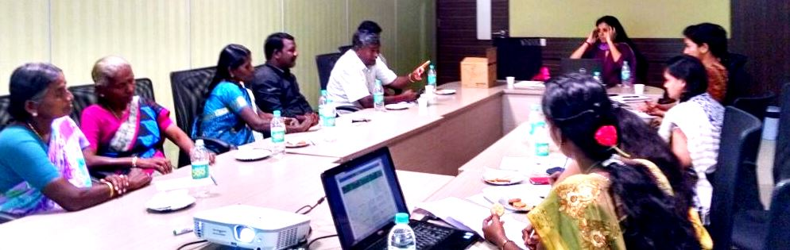
- Distribution of mementos:
